Todd Taylor

Terry Jung

What in the World---Use case And Scenarios

Store Description

Learn the capital cities of the United States and Countries throughout the world in their fun and entertaining quiz game! Score points based on tries to correctly guess the answer and look for hidden clues if you get stumped.. Raise your high score and share it with friends. Will your score top the list?

Potential Users

Adults with children- Any adult with a child might pick this game up to help their child and find it is entertaining for them also

Children ages 8-14—this is the age when you are normally learning about geography and use of electronics and tablets is frequent in this age group.

Persons wanting to re-familiarize themselves with State or World Geography

Anyone just looking for fun facts about states.

**Scenario 1**

**A family is driving to school and the child is restless. A mother gives him her cell phone with what in the world open.**

Use case1- the student opens the world map and has no idea what the capital of Argentina. So he attempts to answer five times and gets them all wrong. Each time wondering and wanting a clue.

Use case2- The student guess wrong on his second guess. He gets frustrated and shakes the device. Upon shaking a hint appears and he is able to guess the country. He is given points on his high score

**Scenario 2**

**A teacher is in class and wants the students to practice their state capitals. The students are supplied with tablets**.

Use case1-The student opens the state geography page, they guess the state and each time the get a brief statement about the state as they wait for the next one.

Use case2- The student opens the world geography page, they guess the state and each time the get a brief statement about the state as they wait for the next one. They get scores as they continue to guess right. Once they get one wrong they lose a life and are given two more lifes.

**Scenario 3**

**A student is looking for state facts to help with a report that they are writing for a geography class.**

Use case1- the student about the home page and clicks on the fact link. They swipe back and forth viewing images of states and facts about them.

Use case2- the students is viewing the state facts and upon setting the device down the accelerometer is activated and a fun fact is revealed. The user then tries other ideas to see if more facts are revealed.

Functionality

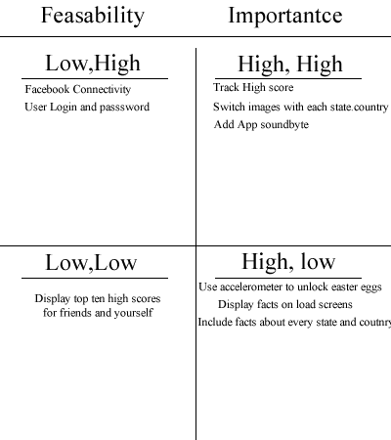

Conceptual Data Model

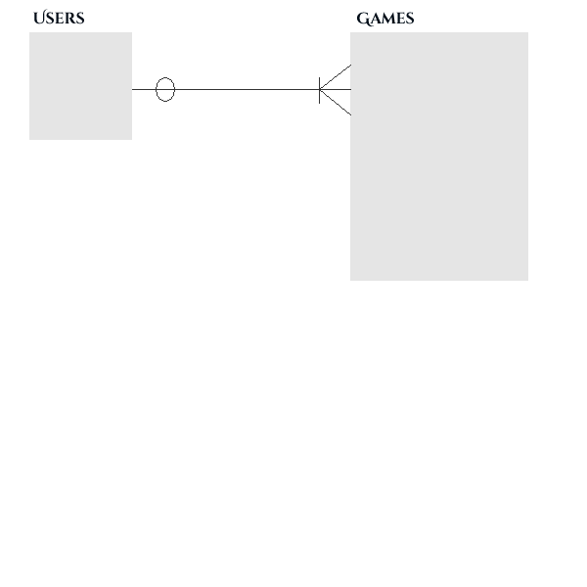

The data model we have so far is relatively simple.

The tables would consist of a users and a scores table.

A user is someone who plays the game and during that game is given a score.

A score is the result of a individuals game score for a given user.

**Fields for Users**

UserID PK

FirstName

Password

**Fields for games**

GameID

GameScore

UserID FK